Onset Date Determination
Ibrahim Dan Dijé, Leon Guy Razafindrakoto

- Statement
This method proposes to assess the early or the late nature of the rainy season onset. The rainy season onset is defined as the date with which the cumulative rainfall of a given year reaches the value of 50mm ([1], [2]). This observed season onset date will be compared to a normal period to define the early or the late nature of the rainy season onset. The normal period of the rainy season onset is defined a lower and an upper bounds. The lower bound of the normal interval corresponds to the rainy season onset date of the 75% curve of the average, and the upper bound corresponds to that of the 125% curve of the average.
The cumulative rainfall of the current year is initiated from the 30th days before the mean onset date
A year with a normal rainy season onset will have a date with which the cumulative precipitation reaches the value 50mm within the normal interval. A year with an early onset will have a date when the cumulative rainfall reaches 50mm before the date corresponding to the lower bound of the normal interval. A year with a late onset has a date when the cumulative rainfall reaches 50mm after the date corresponding to the upper limit of the normal interval.
The data used are the ARC2 data series.
1.1 Description
For a given station data (estimated and/or Observed) time series:
- Calculate the daily mean of the long time series
- Calculate the cumulative of the daily mean and 75%/125% of it.
- Identify the dates on the threshold 50 mm for the mean 75% and 125% of the mean
- We create an interval using the mean onset date and its two boundaries. Set B=Mean Onset (Normal), A=125% Mean Onset (Early), C=75% Mean Onset (Late). The interval is
B
A
C

- Calculate the cumulative of the current year started 30 days before the mean onset:
- If the cumulative reach 50mm (Season Started) then the date D where this threshold is reach is determined.
- The date D is compared within the created interval
- If D < A then the current year has early start.
- If A <= D <= B then the current year has normal to early start.
- If B <= D <= C then the current year has normal to late start.
- If D > C then the current year has late start.
  - Example (Niamey Data)
Let’s consider Niamey Data (Unified precipitation source: https://iridl.ldeo.columbia.edu/SOURCES/.NOAA/.NCEP/.CPC/.UNIFIED_PRCP/.GAUGE_BASED/.GLOBAL/.v1p0/.extREALTIME/.rain/)
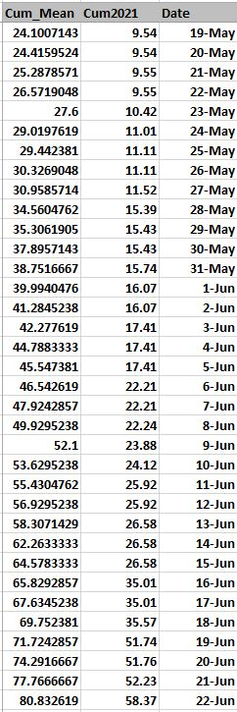

We can see in red circle where the cumulative mean reach 50mm correspond to 9th of Jun and in the blue circle the cumulative of 2021 reach 50mm at 19th of Jun. This shown the late start.
- Algorithm
Input: Historical Station Data, Analogue Years, Season
Output: Onset Date by Year Data Frame

Begin:
-Compute the daily mean (Using long time series)
-Compute the cumulative sum of the daily mean
-Compute 125% and 75% cumulative sum of the daily mean
If (Maximum cumulative sum of the daily mean for a target season >100mm)
- Determine the mean onset date using the cumulative sum of the daily mean (Where it reach 50 mm).
- Determine the late onset and earlier onset using 75% and 125% cumulative sum.
- Using Analogue years and current years
- Start the cumulative sum 30 days before the mean onset date for all the analogue and current year.
- Determine the mean onset for the analogue years where cumulative reach 50mm
- Check if cumulative sum of the current year is greater than 50mm
- The season started then determine the onset date
- If the cumulative sum of the current year is less than 50mm
- The onset date is unknown (N/A) then the station is on onset forecast state.

End.

[1] Lo, F., M. C. Wheeler, H. Meinke, and A. Donald, 2007: Probabilistic forecasts of the onset of the north Australian wet season. Mon. Wea. Rev., 135, 3506–3520.

[2] Ati, O.F.; Stigter, C.J.; Oladipo, E.O. A comparison of methods to determine the onset of the growing season in northern Nigeria.Int. J. Clim. 2002, 22, 731–742.

