AFRICA REGIONAL PLATFORM FOR DISASTER RISK REDUCTION

o TOWARDS DISASTER RISK-INFORMED DEVELOPMENT FOR A RESILIENT AFRICA IN A COVID-19 TRANSFORMED WORLD o
16– 19 NOVEMBER 2021, NAIROBI, KENYA

Concept Note and Guidelines for Stakeholders consultations
(pre-conference, working sessions, special sessions, plenary sessions)

Event title | Africa Multi Hazard Early Warning System for Disaster Risk Reduction (DRR)
Date and Time | 16 November 2021, Time: 15:45-17:00 hours (East African Time (EAT))
Venue/ Room no. | Virtual
UNDRR ROA Focal Point/s | Luca Rossi - Deputy Chief, Regional Office for Africa (RoA), United Nation Office for Disaster Risk Reduction (UNDRR)
Organizers | - The African Union Commission (AUC)  - The Intergovernmental Authority on Development (IGAD) Climate Prediction and Applications Centre (ICPAC)  - United Nation Office for Disaster Risk Reduction (UNDRR)  - Centro Internazionale in Monitoraggio Ambientale (CIMA Research Foundation)
Background and Rational | The AUC, the African Centre of Meteorological Application for Development (ACMAD), IGAD-ICPAC and the Economic Community of Central African States (ECCAS) with the technical support from UNDRR, CIMA and with the contributions from other UN entities, joined efforts in developing an African Road Map for improving the availability, access and use of disaster risk information for early warning and early action in the context of transboundary risk management. These efforts have given birth to the African Multi-Hazard Early Warning System for DRR (AMHEWS for DRR). The system envisages a Situation Room within the AUC that serves as information hub and clearing house, as well as, coordination centre, linked with regional centres in the Regional Economic Communities (RECs) and other Continental Organizations. The Regional Climate Centre of IGAD, ICPAC, and ACMAD, the Continental Climate Centre, are the two first centres operationally connected with the Continental Situation Room.  The situation room of AMHWES for DRR is envisioned to offer multiple information products which are designed specifically for AUC organs, RECs and Member States, as well as, for international organizations engaged in DRR effort. The most prominent products from the situation room to be availed at a regular basis are the Continental watch and Event Situation reports. The Continental Watch (CW) serves to monitor hazards over the continent by issuing continental watch (twice a week); the event situation reports issues updates on current disasters and their related impacts through Event Situation reports. Moreover, the situation room operated under the responsibility of the AUC, will monitor and support the regular exchange and elaboration of data and dissemination of the generated products and services according to agreed Standard operating procedures.  Accordingly, the operation of AMHEWS for DRR faces a number of challenges and opportunities that the side event wants to address:  Standardization of Exchange of Information, warning and alert among different centres from Continental to National level and vice-versa  Coordination and cooperation among all actors for improving trans-boundary risk management  Create and/or strengthen the linkages and exchange between the different DRR offices/institutions within the AUC member states.  Enhance information sharing during disasters and emergences between member states and the African Union Commission  To establish and enhance mechanism for cooperation during emergency preparedness and response
Session Objectives | - To spread awareness on the role of the AMHEWS for DRR -vis à vis Member States and RECs- through a simulation of its daily functioning and support during a fictional ongoing emergency;  - To help identify strengths and areas for improvement in the established AMHEWS for DRR practices (information sharing, standardization of procedures etc.);  - To show inner mechanism of hazard monitoring, alert, science and policy cooperation in regard to prevent disaster risks.  - To test the operability and effectiveness of the existing plans during preparedness and response phases and identify resources gaps
Session format and Programme (detailed agenda) | LIVE Demonstration and presentation (Programme will be defined with the Side Events organization team)
Expected Outcomes | - Show capacity to receive and compile EW data and alarms, as well as to activate advisory support to decision-makers through the AUC situation room functioning during emergencies;  - Show inter-institutional and multi-stakeholder coordination in the AUC situation room functioning.  - Recommendation for upcoming work related to the further implementation of the road map
Key messages | - While ongoing investments to increase field data are expected to generate substantial information in coming years, it is fundamental to grant immediate operational, effective access and use of already existing data and information;  - While further investments are needed to improve capacity to generate and action impact-based EWS, it is equally important to systematize and build upon already existing capacity  - Coordinated access and use of existing capacity is a low hanging fruit which must be exploited: mutual understanding of mandate and capacity for an enhanced coordination mechanism is key to ensure its immediate effective use.
Proposed Moderator of the Session | CIMA Foundation, Chiara Menchise, setting the scene (5 min)
List of Panelists/Speakers and their interventions | The side event will involve (DRAFT):  Remarks by Director General (DG) Italian Agency for Development Cooperation (AICS) - Luca Maestripieri, Video message (5 mins)  Panelists:  - The African Road Map, UNDRR, Diana Patricia Mosquera Calle (7 min)  - Overview of AUC Situation Room, AUC, Lusajo Ambukege (7min)  - ACMAD Forecasting Centre, Dr. Andre Kamga (7min)  - ICPAC Situation Room/Disaster Operation Centre, Dr. Ahmed Amdihun (7 min)  - Africa media monitoring and Demo LIVE Telegram, AUC, Delali Sandra Kemeh (10 min)  Floor intervention:  - ECHO Field Office (5 min)  - Coordinator, Regional Support Office, UN-SPIDER Programme in Nigeria - Dr. Godstime Kadiri James (5 min)  Questions & Answers – (12 min)  Wrap up (5 min)
Reference Documents | The Africa Road Map for improving the availability, access and use of disaster risk information for early warning and early action in the context of transboundary risk management  Standard Operating Procedures (SOPs) for development and dissemination of CWs and Event Situation Reports.
Technical Equipment requirements | UNDRR will support the virtual meeting logistics and provide both French and English interpretation

Contacts:
- Chiara Menchise: chiara.menchise@cimafoundation.org
- Diana Patricia Mosquera Calle: diana.mosquera@un.org / Luca Rossi: rossil@un.org
- Lusajo Ambukege: AmbukegeL@africa-union.org
- Dr Andre Kamga n.godefroid@acmad.org
- Ahmed Amdihun: Ahmed.Amdihun@igad.int
- Sandra Delali kemeh: KemehS@africa-union.org

Panelists
No | Picture | Biography
1 | 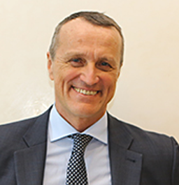 | Luca Maestripieri
2 |  | Diana Patricia Mosquera Calle
3 | 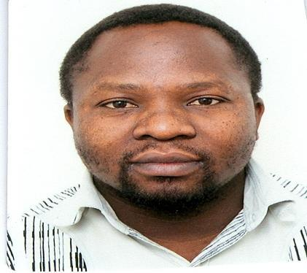 | Lusajo Mwakalesi Ambukege is a disaster Management practitioner with 11 years experience in public office and consultancy. He holds a Bachelors Degree in Geography and Masters Degree in Environment and Natural Resources Management. He is an experienced disaster risk analyst and currently working as a Senior Consultant for the African Union Commission under the Multi- Hazards Early Warning Project.
4 | 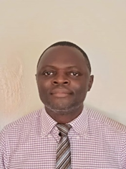
5 |  | Dr.Ahmed Amdihun is a Regional Programme Coordinator for Disaster Risk Management at Intergovernmental Authority on Development (IGAD) Climate Prediction and Applications Centre (ICPAC). Dr.Ahmed has over 12 years of experience on the areas of Disaster Risk Reduction, environmental system modeling, and spatial planning and analysis and capacity development. Before joining IGAD, Ahmed has worked for various national and international organizations at different capacities including United Nations Office for Disaster Risk Reduction, International Livestock Research Institute and Addis Ababa University as Assistant Professor, among others.
6 |  | Sandra Delali Kemeh is a DRR professional with working experience from multiple international development agencies such as the United Nations Office for Disaster Risk Reduction (UNDRR), the United Nations Educational, Scientific and Cultural Organization (UNESCO), and the German development agency (GIZ) on pragmatic approaches in reducing climate exacerbated disaster risks. She has a joint masters in Environmental Risk and Human Security from the United Nations University - Institute of Environment and Human Security and the University of Bonn, Germany.
7 |  | Dr. James is a Spatial Scientist. He holds Bachelor of Science (B.Sc.) degree in Surveying Engineering and Master of Science (M.Sc.) degree in Surveying  and Geoinformatics as well as a Doctor of Philosophy degree (Ph.D.) in Environmental Remote Sensing with emphasis on the integration of geospatial techniques (Remote Sensing and GIS) and economics for  addressing environmental challenges.

