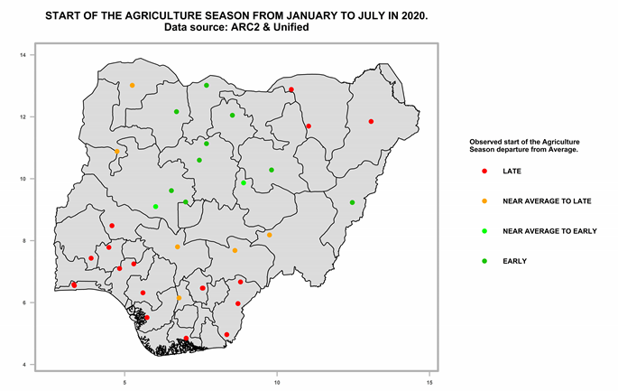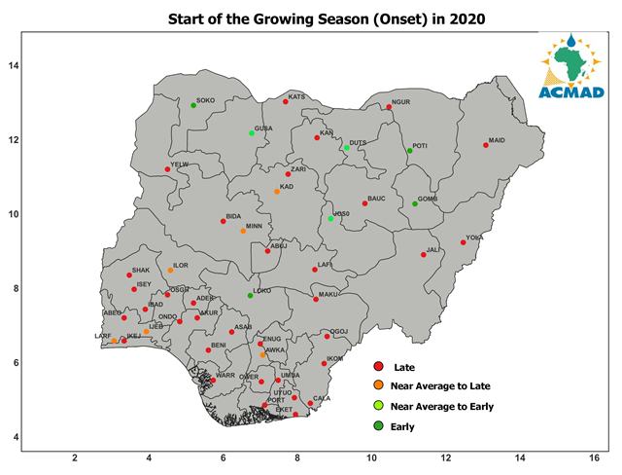
Comparison between the Onset plotting for Nigeria 2020 and 2021 using estimated and observed data. Dataset of ARC2 and UNIFIED Precip (left) and Sation data (right).

