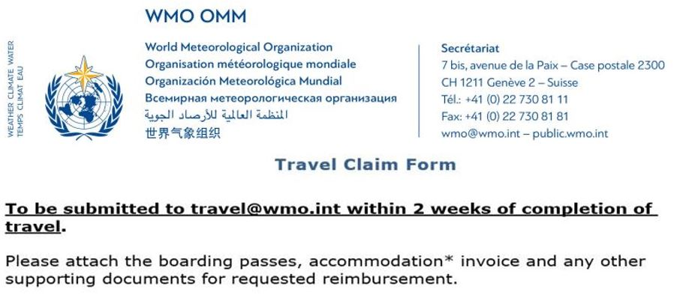

  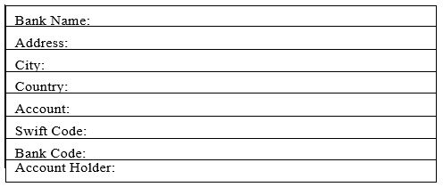
  20192777 - MS
  KAMGA FOAMOUHOUE, Dr Andre
  P.O. Box 13184 Niamey
  Niger

TRV: KAMGA FOAMOUHOUE, Dr Andre_RA I Committee on Infrastructure, Morocco, Casablanca, 29-31/3/2022, Casablanca, Morocco, 29-mar-2022, 31-mar-2022_MS114

